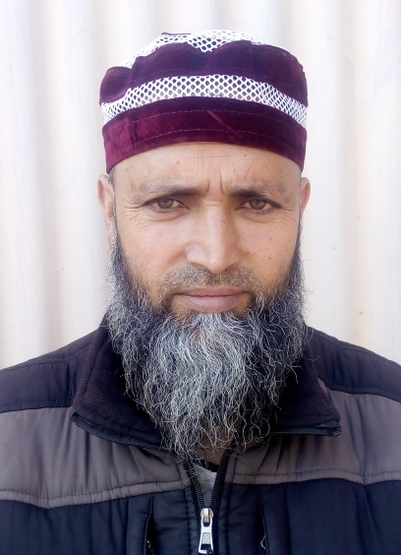
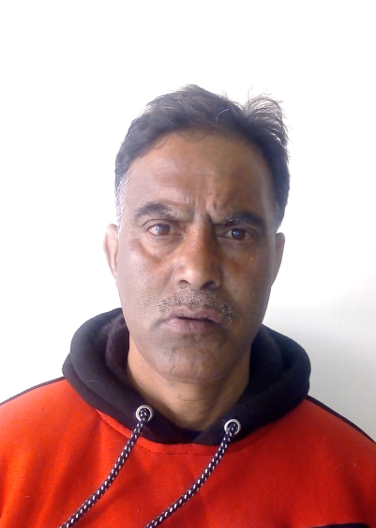

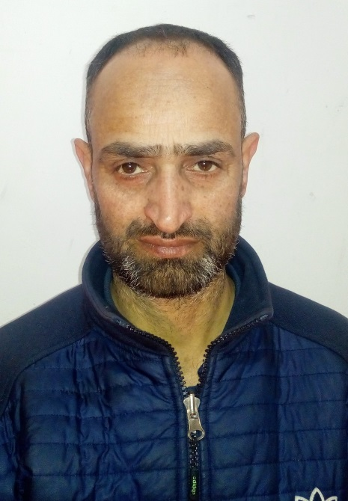

Mr. Ab Rashid Alie
Lab Attendant
Office Orderly
Contact No. 7051557646
Mr. Gh. Jeelani Dar
Lab Attendant
Foundry Lab
Contact No. 7051227945
Mr. Bashir Ahmad Baba
Lab Attendant
Foundry Lab
Contact No. 7889316823
Mr. Mushtaq Ahmad Sheikh
Lab Attendant
Computer Lab
Contact No. 6005777563
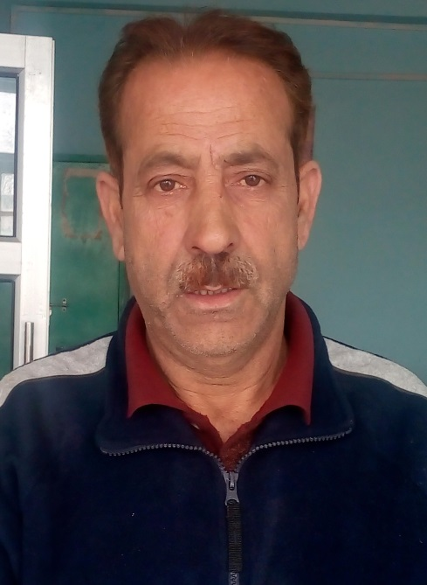
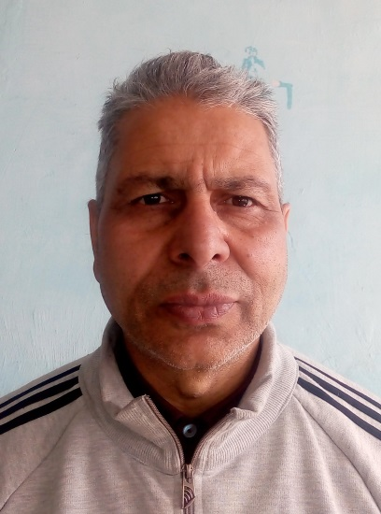
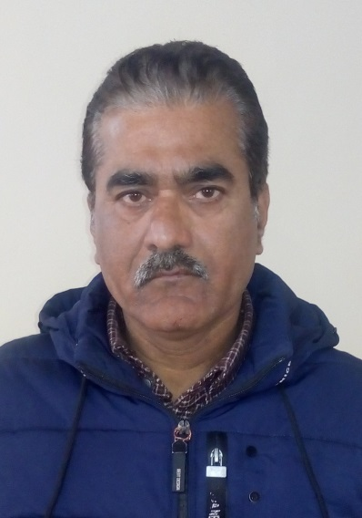
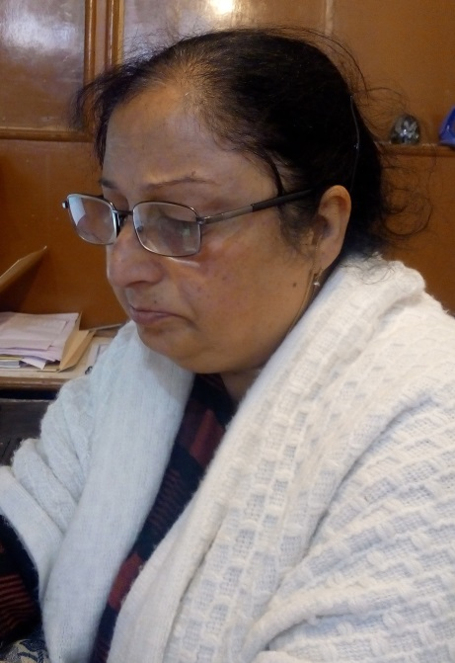
Mr. Jan Mohd Baba
Sr. Technician
Physical Mett. Lab
Contact No. 9103139036
Mr. Gulzar Ahmad Sofi
Sr. Technician
Mech. Mett. Lab
Contact No. 9541130704
Mr. Hilal Ahmad Dar
Sr. Technician
Mineral Dressing Lab
Contact No. 9906479597
Mrs. SunitaDhar (Hak)
Sr. Assistant (Superintendent)
Office
Contact No. 9419355904

